Exercise: ASP.NET Fundamentals
Author: Them Pham |  | Date:09 Jan 2012

Exercise 01: create an ASP.NET form using standard server controls and validations
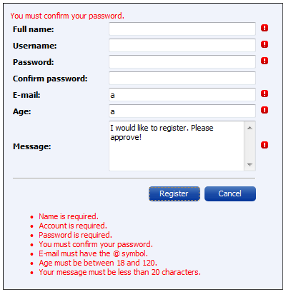
- Create a new ASP.NET Web Site project.
- Add a new ASP.NET page.
- Create a <div> as outer container.
- Create a <table> with 3 columns. The table includes all the input fields and action buttons.
  - Column 1 contains a Label.
  - Column 2 contains an input field (e.g. TextBox).
  - Column 3 contains a validation control to validate the input field.
- Create a ValidationSummary below the table.

Exercise 02: create master page, content pages, themes and skins
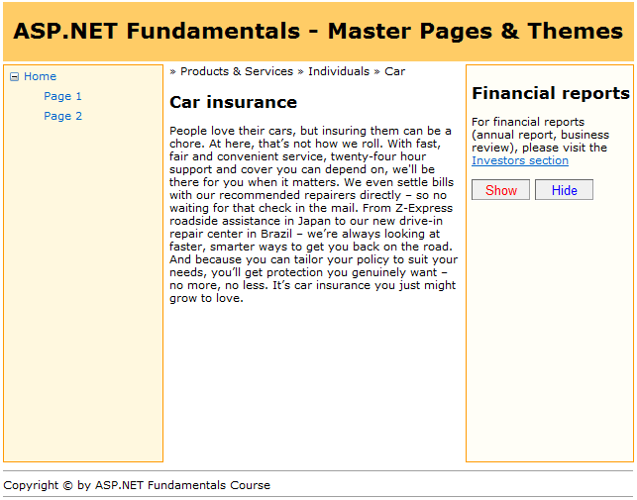
- Create a new ASP.NET Web Site project.
- Create a master page to include 5 <div> with stylesheets defined below.
  - A top-aligned div contains header text.
  - A left-aligned div contains any server controls (e.g. a Label).
  - A center-aligned div contains a ContentPlaceHolder.
  - A right-aligned div contains a ContentPlaceHolder.
  - A bottom-aligned div contains a footer text.
- Create a content page and fill some text to the center ContentPlaceHolder and right ContentPlaceHolder.
- Right ContentPlaceHolder also includes 2 Button to show/hide the control inside the left-aligned div.
- Create a new theme named ‘Modern’. Add a new skin file and a new stylesheet file to the ‘Modern’ folder.
- In the skin file, create 2 new SkinID to control the style of Show/Hide buttons (e.g. fore color and border style).

Exercise 03: create site navigation with TreeView, Menu and SiteMapPath
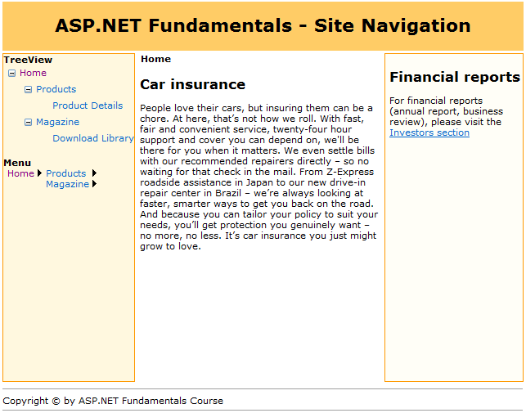
- Reuse exercise 02.
- Add a Web.sitemap file to the project. Define site structure as the tree view.
- Add new content pages as the structure defined to ensure on hyperlink clicked, user can navigate to the target page.
- Declare a SiteMapDataSource in the master page. In master page:
  - Place a TreeView control in the left-aligned div, point to the SiteMapDataSource. Place a Menu (Orientation=Vertical) below the TreeView.
  - Place a breadcrumb (SiteMapPath) at the top of center-aligned div.
- Define two URLs to be remapped (see slide 45) and see how the remapping works.

